
Dashboard Design

Date | 28 October 2026
Team ID | Individual Project
Global Electric Vehicle Market Intelligence Dashboard | Global Electric Vehicle Market Intelligence Dashboard
Maximum Marks | 5 Marks

Activity 1: Interactive and visually appealing dashboards
Creating an effective Streamlit dashboard involves presenting business data stored in Snowflake through clear, interactive, and easy-to-understand visualizations. Students should design the dashboard so that users can quickly understand important KPIs, trends, comparisons, and business insights.
- Clear and Intuitive Layout
- Use Appropriate Visualizations
- Colour and Theming
- Interactive Filters and Slicers
- Drill-Down Capabilities
- Responsive Design
- Custom Visuals and Icons
- Use of Infographics

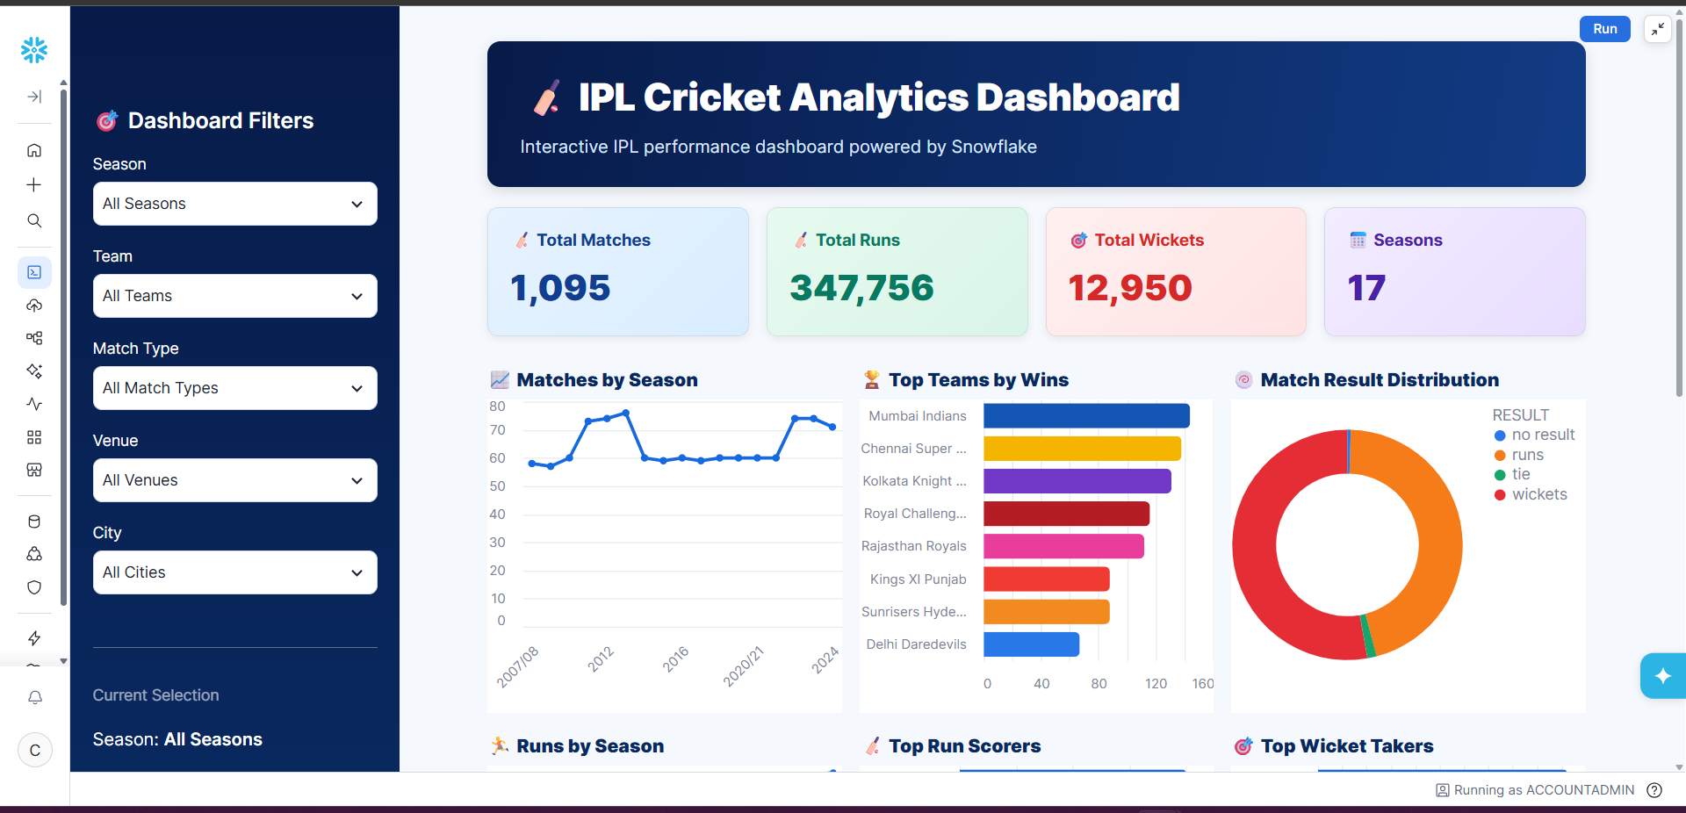
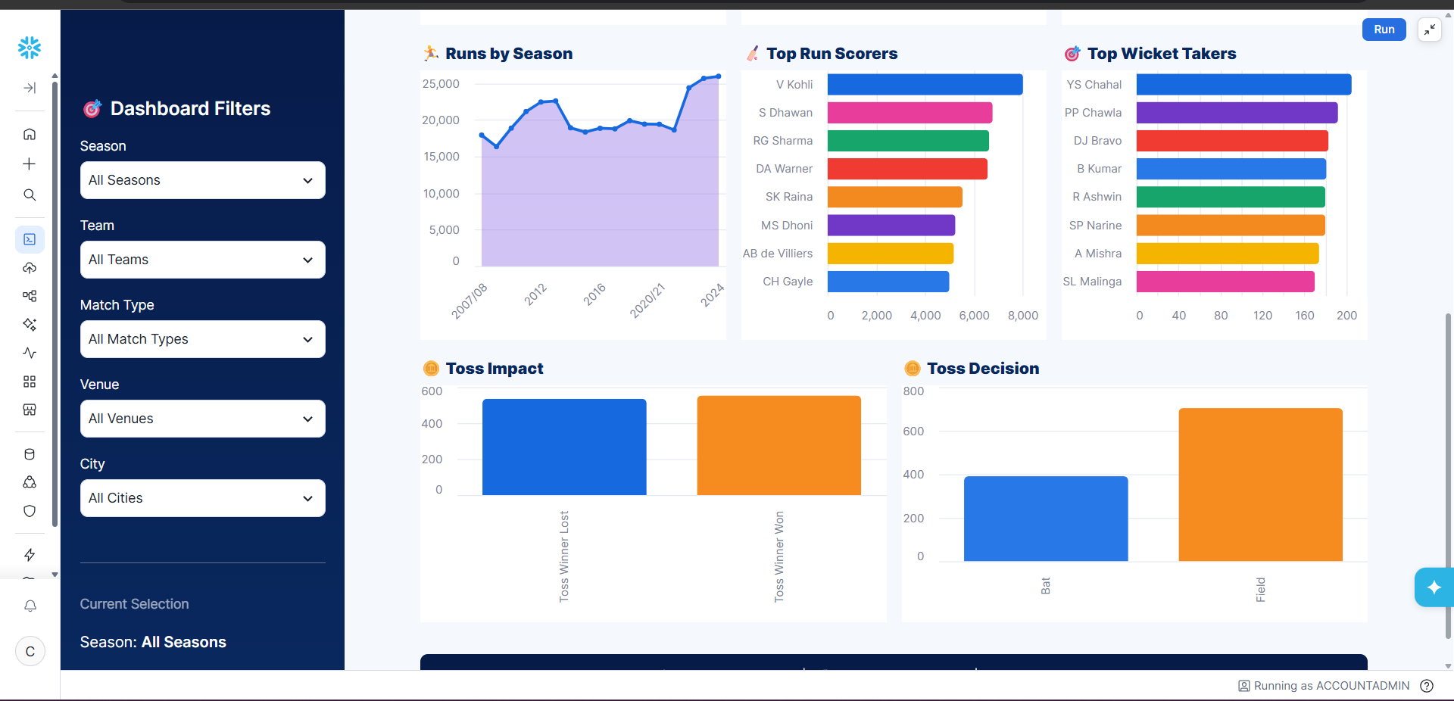
Note: Highlight the major outcomes in form of bullet points
Sample:
Here are five potential outcomes from the dashboard image provided:
- Mumbai Indians emerge as the strongest team by wins
Mumbai Indians are shown at the top of the Top Teams by Wins chart, indicating consistently strong performance across IPL seasons.
- Batting performance is dominated by a few key players
V. Kohli leads the Top Run Scorers chart, followed by players such as S. Dhawan, RG Sharma, and DA Warner. This highlights the importance of high-performing batsmen.
- Wicket-taking performance is concentrated among leading bowlers
YS Chahal ranks highest in the Top Wicket Takers chart, followed by PP Chawla and DJ Bravo, indicating that a relatively small group of bowlers has contributed significantly to wicket-taking.
- Fielding/toss decisions appear to have an impact on match outcomes
The Toss Impact and Toss Decision charts show differences between winning after winning the toss and choosing to bat vs. field. This can be used to investigate whether the toss provides a meaningful advantage.
- IPL match activity and scoring have grown over the seasons
The Matches by Season and Runs by Season charts show variation and an overall increase in IPL activity and run production across seasons, with particularly high run totals in later seasons.
Overall outcome: The dashboard suggests that IPL success is influenced by a combination of strong teams, elite batting and bowling performers, match/toss decisions, and changing scoring patterns across seasons.

Dashboard Design — EV Market Intelligence
Layout: top row KPI cards (annual sales, number of models, average range, average rating where available); middle row annual trend and category/manufacturer rankings; lower row battery mix, range comparison, country distribution, and ratings.
Filters: year, vehicle category, manufacturer, battery technology, and manufacturing country, subject to fields available in the dataset.
Visual standards: consistent units and number formats; descriptive titles; accessible colors; tooltips showing relevant context; avoid decorative 3D charts.
Major outcomes to test and report: leading category by sales; top manufacturer by sales; battery technology distribution; range differences across categories; geographic production patterns; customer-rating variation.
No numerical outcomes are asserted until the real dataset is loaded and the dashboard is validated.
Activity 2 — Tableau Public: publish only after the workbook is complete and the account/course rules permit it. Public URL: not yet available; insert the real link after publication.
Student: Harsh Agrawal
Project: Global Electric Vehicle Market Intelligence Dashboard

